CHITKARA INSTITUTE

OF

ENGINEERING & TECHNOLOGY

PRACTICAL FILE

SUBJECT:PROBLEM SOLVING TECHNIQUE USING C

COURSE NO:CSP- 2201

[B.E(CSE)-IIIrd SEMESTER]

SUBMITTED TO: SUBMITTED BY:
Mrs. Neha Gupta Mayank Gautam
A.P. 1510991373

14. Write a C program to find the factorial of a number, where the number is entered by user.
CODE:
#include<stdio.h>
void main()
{
int a,i=0,b,c;
printf("Enter the number ");
scanf("%d",&b);
a=b;
c=fact(a);
printf("%d! = %d",b,c);
}
int fact(int a){
for(i=1;i<b;i++){
a=a*i;
}
return a;
}

OUTPUT:
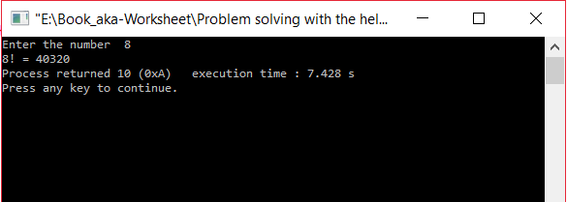
15. Write a program to check whether a number is palindrome or not.
CODE:-
#include<stdio.h>
void main(){
int num,r,sum=0,temp;
printf("Enter a number= ");
scanf("%d",&num);
temp=num;
while(num)
{
r=num%10;
num=num/10;
sum=sum*10+r;
}
if(temp==sum)
printf("%d is a palindrome",temp);
else
printf("%d is not a palindrome",temp);
}

OUTPUT:-
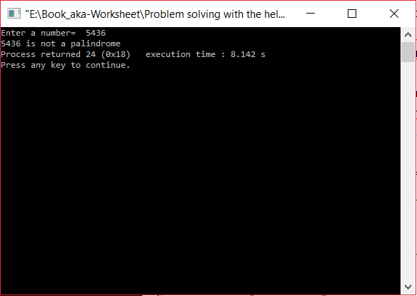

16. Write a program to calculate GCD of two numbers using Euclid’s algorithm. Write a program to calculate GCD of two numbers using Euclid’s algorithm.
CODE:
#include<stdio.h>
void main()
{
int a,b;
void gcd(int , int);
printf("Enter two numbers ");
scanf("%d%d",&a,&b);
gcd(a,b);
}
void gcd(int a,int b)
{
int q,rem;
while (a!=0 && b!=0){
q=a/b;
rem=a%b;
a=b;
b=rem;
}
if(a==0){
printf("GCD is %d",b);
}
else if (b==0){
printf("GCD is %d",a);
}
}
OUTPUT:
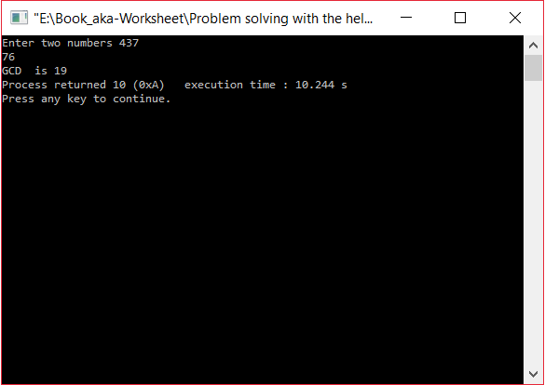

17. Write a program to find first 100 prime numbers (using square root method).
Note:Compare it with other methods and its effectiveness over other method.
CODE:
#include<stdio.h>
int main()
{
void prime();
prime();
}
void prime()
{
int i=1,j,c=0,flag=0;
while (c<101)
{
for (j=1;j<=i;j++)
{
if(i%j==0){
flag=flag+1;
}
}
if(flag==2){
printf("%d , ",i);
c=c+1;
}
i=i+1;
flag=0;
}
}
OUTPUT:
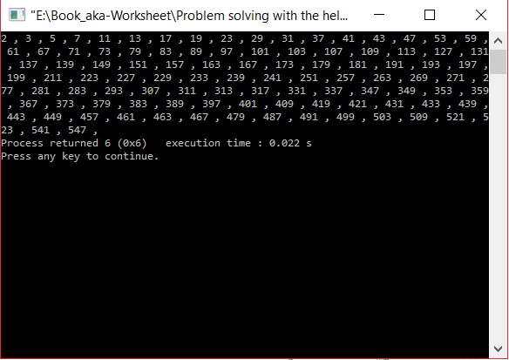

18. Write a program to Display Fibonacci Series.
CODE:
#include<stdio.h>
void main()
{
int a=0,b=1,n,c,i;
printf("ENTER THE SIZE OF SERIES:");
scanf("%d",&n);
printf("\t%d \t%d",a,b);
c=a+b;
printf("\t%d",c);
for(i=1;i<=n;i++)
{
a=b;
b=c;
c=a+b;
printf("\t%d",c);
}

OUTPUT:
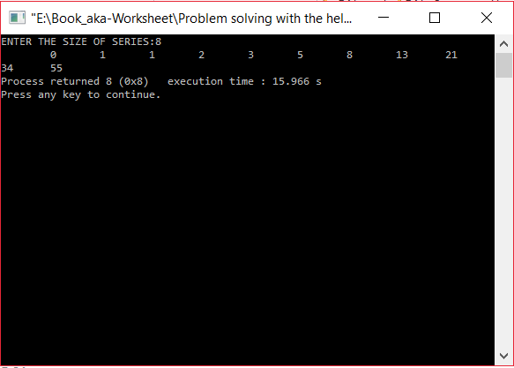

19. Write a program to find whether a number is Armstrong or not.
CODE:
#include<stdio.h>
int main(){
int num,r,sum=0,i;
printf("Enter a number= ");
scanf("%d",&num);
for(i=num;i>0;i=i/10)
{
r=i%10;
sum=sum+(r*r*r);
}
if(sum==num)
printf("Is a Armstrong");
else
printf("Is not a Armstrong");
}
OUTPUT:
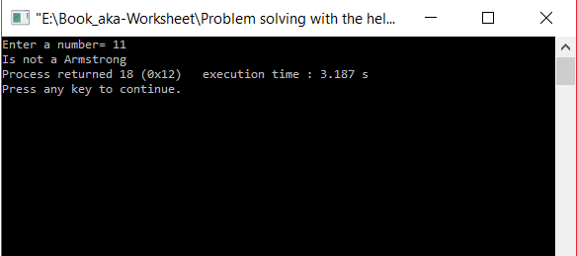
20. Write a program to convert binary number to decimal number and decimal number to binary number.
CODE:
#include<stdio.h>
void main()
{
int num, binary_val, decimal_val = 0, base = 1, rem;
long int decimalNumber,remainder,quotient;
int binaryNumber[100],i=1,j;
printf("Enter a binary number(1s and 0s) \n");
scanf("%d", &num);
binary_val = num;
while (num > 0)
{
rem = num % 10;
decimal_val = decimal_val + rem * base;
num = num / 10 ;
base = base * 2;
}
printf("The Binary number is = %d \n", binary_val);
printf("Its decimal equivalent is = %d \n", decimal_val);
printf("\n\n");
printf("Enter any decimal number: ");
scanf("%ld",&decimalNumber);
quotient = decimalNumber;
while(quotient!=0)
{
binaryNumber[i++]= quotient % 2;
quotient = quotient / 2;
}
printf("Equivalent binary value of decimal number %d: ",decimalNumber);
for(j = i -1 ;j> 0;j--)
{
printf("%d",binaryNumber[j]);
}
}
OUTPUT:
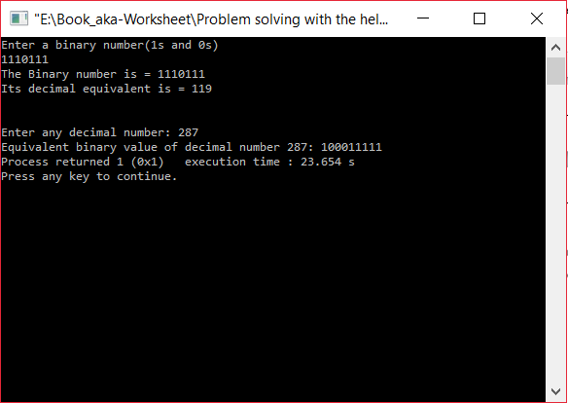

21. Write a program to convert octal number to decimal number and decimal number to octal number.
CODE:
#include <stdio.h>
#include<math.h>
#include<string.h>
void main()
{
long decimalnum, remainder, quotient;
int octalNumber[100], i = 1, j;
long int octal, decimal = 0;
int k = 0;
printf("Enter the decimal number: ");
scanf("%ld", &decimalnum);
quotient = decimalnum;
while (quotient != 0)
{
octalNumber[i++] = quotient % 8;
quotient = quotient / 8;
}
printf("Equivalent octal value of decimal no %d: ", decimalnum);
for (j = i - 1; j > 0; j--)
printf("%d", octalNumber[j]);
printf("\n \n");
printf("Enter any octal number: ");
scanf("%ld", &octal);
while (octal != 0)
{
decimal = decimal +(octal % 10)* pow(8, k++);
octal = octal / 10;
}
printf("Equivalent decimal value: %ld",decimal);
}
OUTPUT:
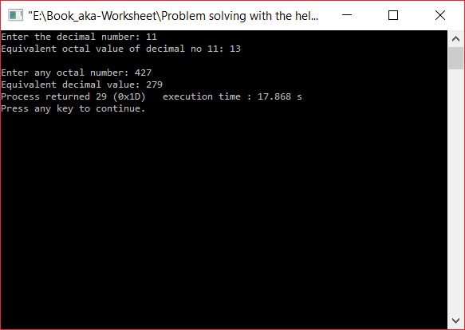

22. Write a program to swap numbers in cyclic order using call by reference.
CODE:
#include<stdio.h>
void swap(int,int);
void main()
{
int a,b;
printf("ENTER 2 NUMBERS: ");
scanf("%d %d",&a,&b);
printf("BEFORE SWAPPING: a = %d and b = %d \n",a,b);
swap(a,b);
}
void swap(int a,int b)
{
int temp;
temp=a;
a=b;
b=temp;
printf("AFTER SWAPPING: a = %d and b = %d \n",a,b);
}

OUTPUT :
